**Project Design Phase-II Data Flow Diagram & User Stories**

|  |  |
| --- | --- |
| Date | 15 October 2022 |
| Team ID | PNT2022TMID22506 |
| Project Name | AI-powered Nutrition Analyzer for Fitness Enthusiasts |
| Maximum Marks | 4 Marks |

**Data Flow Diagrams:**

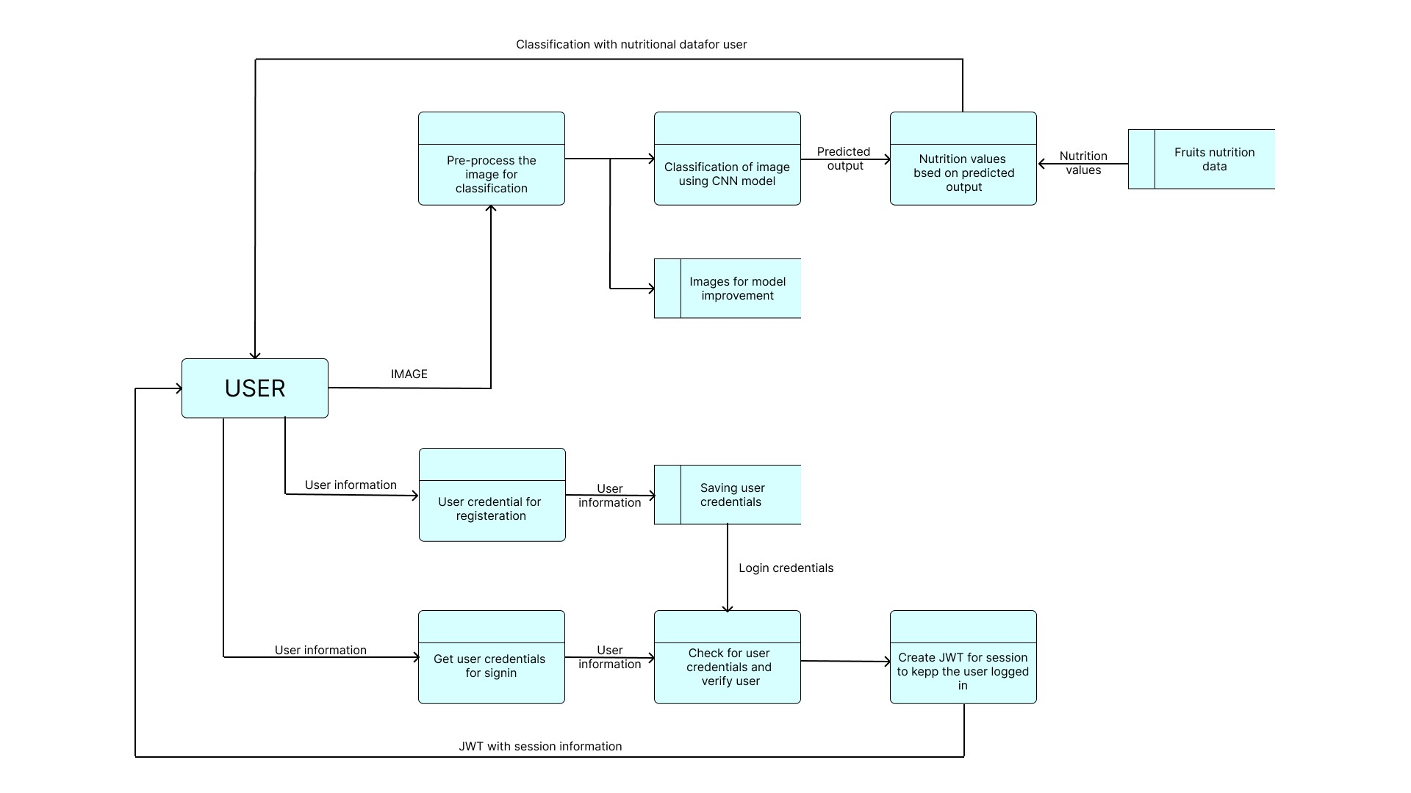

**User Stories**

|  |  |  |  |  |  |  |
| --- | --- | --- | --- | --- | --- | --- |
| **User Type** | **Functional**  **Requirement**  **(Epic)** | **User Story**  **Number** | **User Story / Task** | **Acceptance criteria** | **Priority** | **Release** |
| Customer (Web user) | Registration and login | USN-1 | As a user, I can register for the application by entering a unique user id, password, and confirming my password. | I can access my account / dashboard | High | Sprint-1 |
| Common to all | Main page, About  Page | USN-2 | Home page, About page. Navigate through the application easily ( easy user experience and interface). | All can access home page, about page | High | Sprint-1 |
| Customer | Prediction | UNS-3 | As a user, I can upload pictures from the camera and also from the device. | I can upload picture from my gallery and camera | HIgh | Sprint-2 |
| Customer | Anonymous Usage | USN-4 | As a user, I can access the application without signing in. | I can access the application without authentication | High | Sprint-2 |
| Customer | Logout | USN-5 | As a user, I can logout from the application | I can logout | High | Sprint-1 |
| Customer | Searching fruits data manually | USN-6 | As a user, I can access information (nutritional Content) about other fruits also in the application. | I can access the nutrition informations of fruit | Medium | Sprint-2 |
| Customer | Motivational quotes suggestion | USN-7 | As a user, I get daily motivational quotes. | I can get daily motivational quotes | High | Sprint-2 |
| Customer | Searching | USN-8 | As a user, I can get suggestion of fruits based on season and health condition | I can get fruit suggestion based on season and health condition | High | Sprint-2 |
| Customer | Health details management | USN-9 | As a user , I can manage my health condition  details like diabetic details through accessing the health management page | I can manage my health condition page | Medium | Sprint-3 |
| Customer | Monitoring | USN-10 | As a user, I can monitor my daily water intake as per my body weight, and get periodic reminders. | I can get periodic notifications for water intake reminder. | Medium | Sprint-3 |
| Customer | Dashboard | USN-11 | As a User I can view the nutritional content of food taken for an day | I can monitor my daily nutrition intake. | Low | Sprint-2 |
| Common to all | Report page | USN-12 | As a User I can report any issues through report page | I can report any issues through the report page | High | Sprint2 |
| Customer  (Mobile user) | Installable PWA | USN-13 | PWA for mobile users | I can install app from any browser | Medium | Sprint-3 |

|  |  |  |  |  |  |  |
| --- | --- | --- | --- | --- | --- | --- |
| **User Type** | **Functional**  **Requirement**  **(Epic)** | **User Story**  **Number** | **User Story / Task** | **Acceptance criteria** | **Priority** | **Release** |
| Technical team | Dashboard | USN-14 | As a User I can View the issues and reports done by common users and the administrator | I can view issues and reports | High | Sprint-2 |
| Administrator | Dashboard | USN-15 | As a Administrator I can view and manage users, contents | I can manage users and contents in the application | Medium | Sprint-3 |
| Common to all | Feedback page | USN-16 | As a User I can give Feedback. | I can give feedback on any content or event | Medium | Sprint-3 |
| Customer | BMI update page | USN-17 | As a User I can update and view my BMI | I can access my BMI | Medium | Sprint-3 |
| Administrator | Security Check | USN-18 | As a administrator I need to confirm that the users data are in secure format | I need to conform data security | Medium | Sprint-4 |
| Customer | Grouping Users | USN-19 | As a user, i can join or enroll in a group to get specialized content | I can join to groups | Low | Sprint-4 |
| Customer | Storing Data | USN-20 | As a user, i can store the data which are used to predict the health conditions | I can store data i used in this application | Medium | Sprint-3 |